**Project Initialization and Planning Phase**

| Date | 15 March 2024 |
| --- | --- |
| Team ID | 739724 |
| Project Name | Analysis of amazon cell phone reviews |
| Maximum Marks | 3 Marks |

**Define Problem Statements (Customer Problem Statement Template):**

From the customer side, purchasing a cell phone online can be overwhelming due to the vast number of options available. Customers often rely heavily on reviews to make decisions. However, the sheer volume of reviews can be difficult to analyze. Some reviews might be vague, misleading, or irrelevant. In the absence of a clear analysis, customers struggle to differentiate between genuine feedback and promotional content. A typical customer might have several pain points:

* **Difficulty in Trusting Reviews**: Customers may be unsure if reviews are genuine or biased.
* **Overwhelming Amount of Information**: There are often thousands of reviews for a single product, making it difficult to sift through them for useful insights.
* **Lack of Clear Patterns**: Negative or positive sentiments can be scattered across reviews without a clear understanding of which features are the most important to focus on.
* **Inability to Identify Specific Needs**: Customers may not easily find reviews that match their specific preferences or needs (e.g., camera quality for photography lovers, battery life for heavy users).

**Image Description (Customer Perspective):**

Imagine a frustrated customer trying to decide on a new cell phone. They are sitting in front of a computer or mobile device, looking at a product page filled with hundreds of Amazon reviews. The reviews are scattered and disorganized, some are long and detailed, others are brief, making it difficult to find relevant information. The customer feels overwhelmed, unsure which phone to buy, and uncertain if the reviews are reliable. Some reviews are positive, but the customer doesn't know if those feedback points apply to their specific needs, while others are negative, leaving them confused about whether the issues mentioned are critical or not.

The image should reflect:

* A customer scrolling through an Amazon product page with numerous reviews.
* Frustration or confusion, perhaps shown with a person holding their head or looking puzzled at the screen.
* A jumble of text bubbles with stars, emojis, and words like "Good," "Bad," and "Great," but no clear trends or insights.
* A sense of overwhelm from having to filter through so many reviews.

Reference: https://miro.com/templates/customer-problem-statement/

**Example:**

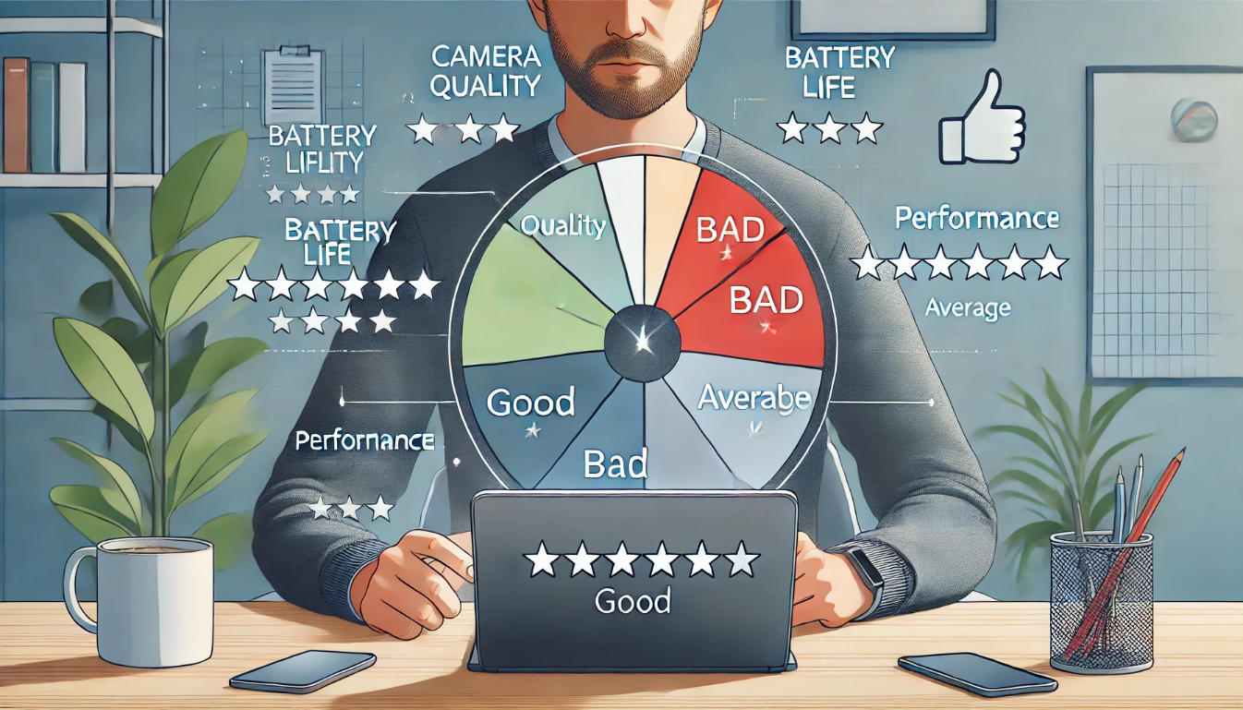

|  |  |  |  |  |  |
| --- | --- | --- | --- | --- | --- |
| **Problem**  **Statement (PS)** | **I am**  **(Customer)** | **I’m trying to** | **But** | **Because** | **Which makes me feel** |
| PS-1 | A smartphone buyer | Find a reliable phone that fits my needs | Reviews are overwhelming and scattered | I can’t identify key insights or patterns | Confused and frustrated |
| PS-2 | A tech enthusiast | Choose a phone with excellent camera quality | It's hard to find reviews matching my preferences | Most reviews are  Irrelevant or vague | Uncertain about making the right choice |